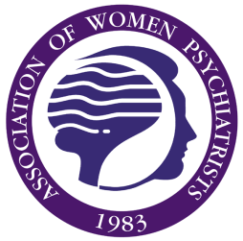
Association of Women Psychiatrists
P.O. Box 570218 • Dallas, Texas 75357-0218
972-613-0985 • Fax: 972-613-5532 • Email: womenpsych@aol.com

January 13, 2021

Dear Colleague:

The Association of Women Psychiatrists is pleased to announce its annual call
for applications for the AWP Fellowship funded by the Alexandra and Martin Symonds
Foundation Fellowship. Two outstanding women psychiatric residents/fellows will be
selected for these Fellowship Programs. Candidates will be selected based on
demonstrated leadership potential, interest in and commitment to women’s health, and
community mental health service, with a focus on gender issues and advancing women’s mental health in the fields of clinical services, research, and educational excellence.

The Association of Women Psychiatrists seeks to improve communication among
women in psychiatry with a goal of advancing more women into leadership
positions in all aspects of health care. Additionally, the AWP seeks to provide
support for women at all levels of their career and serve as a resource to disseminate
information on women’s health issues to its membership and beyond.

We invite you to nominate a psychiatry resident/fellow for this award and will accept one application per training program. The recipients will each receive a $1,500 award. Fellowship winners are expected to remain active within the AWP including committee work in the year following the award and active participation in the AWP mentorship network in subsequent years.

The applications with all supporting documents must be submitted as a single PDF file to womenpsych@aol.com by March 31

AWP Executive Council

